Homework 2

**Day of the Week**

Write a program that asks the user for a number in the range of 1 through 7. The program should display the corresponding day of the week, where 1 = Monday, 2 = Tuesday, 3 = Wednesday, 4 = Thursday, 5 = Friday, 6 = Saturday, and 7 = Sunday. The program should display an error message if the user enters a number that is outside the range of 1 through 7.

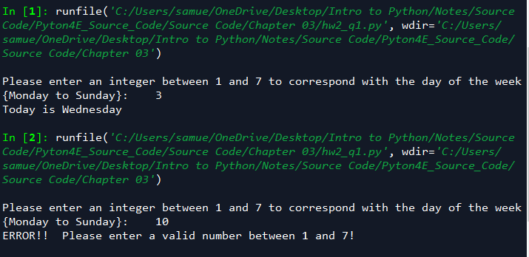

**Age Classifier**

Write a program that asks the user to enter a person’s age. The program should display a message indicating whether the person is an infant, a child, a teenager, or an adult. Following are the guidelines:

* If the person is 1 year old or less, he or she is an infant.
* If the person is older than 1 year, but younger than 13 years, he or she is a child.
* If the person is at least 13 years old, but less than 20 years old, he or she is a teenager.
* If the person is at least 20 years old, he or she is an adult.

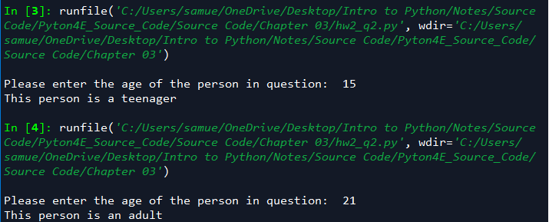

**Color Mixer**

The colors red, blue, and yellow are known as the primary colors because they cannot be made by mixing other colors. When you mix two primary colors, you get a secondary color, as shown here:

* When you mix red and blue, you get purple.
* When you mix red and yellow, you get orange.
* When you mix blue and yellow, you get green.

Design a program that prompts the user to enter the names of two primary colors to mix. If the user enters anything other than “red,” “blue,” or “yellow,” the program should display an error message. Otherwise, the program should display the name of the secondary color that results.

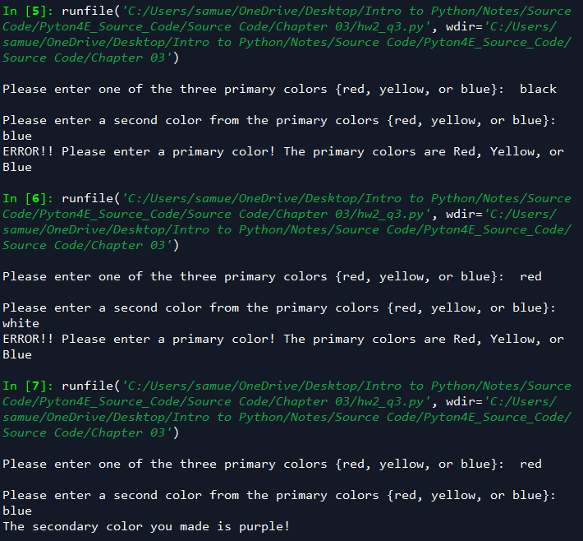

Please create a python code for each program, and make a screen capture to paste in this word file. Then please turn in the word file and a zip file with .py codes.